To confirm your attendance, please fill in this form and have it sent to cge@emp.mdn.dz by March 25, 2019
“’
Status * | Author Participant
Title * | Prof. Dr. Student Other
CEE Paper Number
Name(First and Last) *
Gender * | Female Male
Institution *
Phone *
Email *
Arrival Date * | 21/04/2019 22/04/2019 23/04/2019
Arrival Hour *
Departure Date * | 22/04/2019 23/04/2019 24/04/2019
Departure Hour *
Registration packages: (All registration packages include the conference bag, and give access to all conference sessions, tutorials, lunches and coffee breaks).  Payment can be done either way:  Bank transfer(recommended, clearly specify the reason “CEE-2019 Registration”) to:  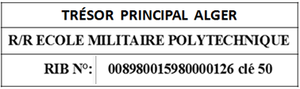  On site | Please choose your package:  Participation fees without accommodation  Standard registration: 8.000 DZD  Student registration: 5.000 DZD  Free Listener registration: 8.000 DZD  Participation fees with accommodation  Standard registration: 20.000 DZD  Student registration: 15.000 DZD

please provide the receipt

