To confirm your attendance, fill in this form and have it sent to csa@emp.edu.dz by November 20, 2016
“’
Status * | Author Participant
Title * | Prof. Dr. Student Other
CSA Paper Number
Name (First and Last) *
Gender * | Female Male
Institution *
Phone *
Email *
Arrival Date * | 12/12/2016 13/12/2016 14/12/2016
Arrival Hour *
Departure Date * | 13/12/2016 14/12/2016 15/12/2016
Departure Hour *
Registration packages: (all registration packages include conference bag and give access to all conference sessions, tutorials, lunches, and coffee breaks).  Payment can be done either way:  Bank transfer (recommended, clearly specify the reason “CSA-2016 Registration”) to:  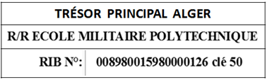  On site | Please choose your package:  Full registration: 10.000 DZD (including  up to 2-night accommodation, upon prior acceptance of Conference Chairs)  Regular registration: 8.000 DZD  Student registration (requires student  proof): 6.000 DZD  Non-author registration: 8.000 DZD

please provide the receipt

