To confirm your attendance, please fill in this form and have it sent to csa@emp.edu.dz by March 20, 2018
“’
Status * | Author Participant
Title * | Prof.Dr. Student Other
CSA Paper Number
Name(First and Last) *
Gender * | FemaleMale
Institution *
Phone *
Email *
Arrival Date * | 23/04/2018 24/04/2018 25/04/2018
Arrival Hour *
Departure Date * | 24/04/2018 25/04/2018 26/04/2018
Departure Hour *
Registration packages: (All registration packages include the conference bag, and give access to all conference sessions, tutorials, lunches and coffee breaks).  Payment can be done either way:  Bank transfer(recommended, clearly specify the reason “CSA-2018 Registration”) to:  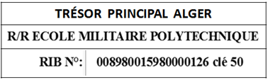  On site | Please choose your package:  Full registration: 12.000 DZD (including  up to 2-night accommodation, upon prior acceptance of Conference Chairs)  Regular registration: 8.000 DZD  Student registration: 6.000 DZD (requires  student proof)  Non-author registration: 12.000 DZD

please provide the receipt

