*
ª Faculty of Mechanical Engineering, University of Technology, Address, Postcode City, Country
^{b} Institute for Mechatronics, University of Technology, Address, Postcode City, Country
^{c} Institute of Mechanics, University of Technology, Address, Postcode City, Country

* Corresponding author. Tel.: ; E-mail address:
ABSTRACT
The paper should be formatted according to the conference style guidelines presented in this template. The title of the paper should be typed in 16pt bold font and centered. It should be separated from the author names by 14pt space. Author names should be typed in bold font, in addition, the name of the presenting author should be underlined. It should be separated from the affiliations by 16pt space. Affiliations should be typed in general formatting style, centered within a corresponding bounding box. The abstract part of the final paper should be formatted as one paragraph not longer than 300 words and it should fit to the title page. The abstract begins with the "ABSTRACT" header typed in bold 10pt font. The abstract text should be separated from the header by 10pt space. Title, affiliations and abstract have to fit to the title page.

Keywords:

INTRODUCTION
All text should be written in the Times New Roman font. General text should be justified and divided into logical paragraphs separated by 10pt spaces. Single line spaces are required. All section headers except abstract and references header should be numbered using Arabic numbers without a trailing dot. The headers are separated from the last preceding paragraph by 24pt space and the following text by 10pt space. Top level headers should be typed in capital characters. Subsections should be numbered using multilevel numbering. A maximum of two sublevels is allowed. Subheaders should be typed in normal word case. A font size of 10pt should be used if not specified otherwise. The subsection headers are separated from the the last preceding paragraph by 12pt space and the following text by 6pt space.
Here put a nomenclature if necessary, in a box with the same font size as the rest of the paper.

Nomenclature
A radius of
B position of
C further nomenclature continues down the page inside the text box

GENERAL INSTRUCTIONS
The paper must be written in English. The total length of the paper may not exceed 10 pages. The top page margin should be 18mm, others 30mm. The paper used should have the size 210 x 297mm which is the European A4 size. It is suggested to use styles for formatting, automatic reference and figure numbering to avoid editorial errors. To avoid compatibility problems it is advised to use only the Latin alphabet and underscore character in the file name.

Equations
Equations and formulas should be typed in Mathtype, and numbered consecutively with Arabic numerals in parentheses on the right hand side of the page (if referred to explicitly in the text) as shown in Equation (1). They can also be build with the Microsoft Equation Editor using the following sizes: Full 11pt, Subscript/Superscript 7pt, Sub-Subscript/Superscript 5pt, Symbols 16pt and Sub-Symbols 11pt. Equations must be separated from the surrounding text by one space.
(1)
All symbols of the equation should be explained.

Figures and tables
Figures and graphs must be included using the same style as shown in Figure 1. The contents of the Figure should be explained in its caption.
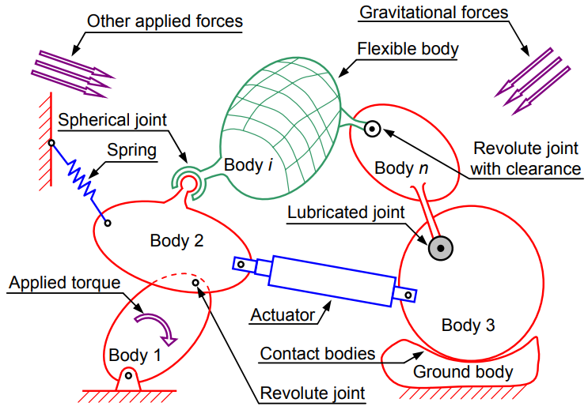
Figure 1. Abstract representation of a multibody system with its most significant components: bodies, joints and forces elements (example of a figure and its caption).
A resolution of 300dpi for pictures and 600dpi for line art is suggested, 1px wide lines in figures should be avoided as they may become invisible in print. There is no limit on the number of figures as long as the total length of the paper is within the specified limit. Figures should be centered on the page.

Tables must be included using the same style as shown in Table 1. The contents of the table should be explained in its header. Tables should be centered.

Table 1. Example of a table.
T11 | T12 | T13 | T14
T21 | T22 | T23 | T24

References
References should be sorted in alphabetical order as shown below, where ‎[1] exemplifies the case of a textbook, while ‎[3] is an article in conference proceedings and ‎[2] is an article in a journal.

SUBMISSION OF THE PAPER
Authors are requested to upload a paper of a maximum length of 10 pages including references and figures no later than 01st February 2026, to the conference web page. The uploaded file must be in the PDF format and the file size should be below the limit of 5MB. When creating the PDF, please make sure to use A4 as paper size.

After successful submission the author will receive a submission confirmation email within 24h. Before submitting your paper, please make sure that it is according to the conference style guidelines presented in this template.

CONCLUSIONS
We are looking forward to meeting you at the conference in Bordj El-Bahri.
REFERENCES
- Bauchau, O.A.: Flexible Multibody Dynamics. Dodrecht: Springer, 2011.
- Mikkola, A.M.; Shabana, A.A.: A Non-Incremental Finite Element Procedure for the Analysis of Large Deformation of Plates and Shells in Mechanical System Applications. Multibody System Dynamics, Vol. 9, No. 3, pp. 283-309, 2003.
- Seifried, R.; Schiehlen, W.: Computational Analysis and Experimental Investigations of Impacts in Multibody Systems. In P. Eberhard (Ed.) IUTAM Symposium on Multiscale Problems in Multibody System Contacts, pp. 269-280, Springer 2007.

